Taylor Shellfish Hatchery

Durafet Calibration Procedure

Created by: Rhonda Elliott

February 2, 2016

When you take the Durafet straight out of the box, the electrode needs to condition for about a week in seawater. So while you can calibrate it right away to use if you need to, you should recalibrate after one week.

**Cleaning:** Use a light acid bath solution (0.1% HCl) to clean off the tip of the Durafet if there is any biofouling. I use a squirt bottle to clean the sensor as to apply a little bit of pressure to clean it without actually touching it. I use a Q-tip to wipe off any residual film surrounding it taking care to not touch the sensor. The Durafet should never be stored in freshwater; use seawater.

**Calibrating:** The temperature sensor in the Durafet probe is located in the center about 2 inches up from the tip of the probe. Therefore when calibrating or analyzing water pH you must have the bottom two inches of the probe submerged to detect the correct temperature. We have a continuous monitoring set-up for shallow and deep water at our hatchery (Photo 1). Notice the seawater being measured is surrounding the last two inches of the Durafet probe.

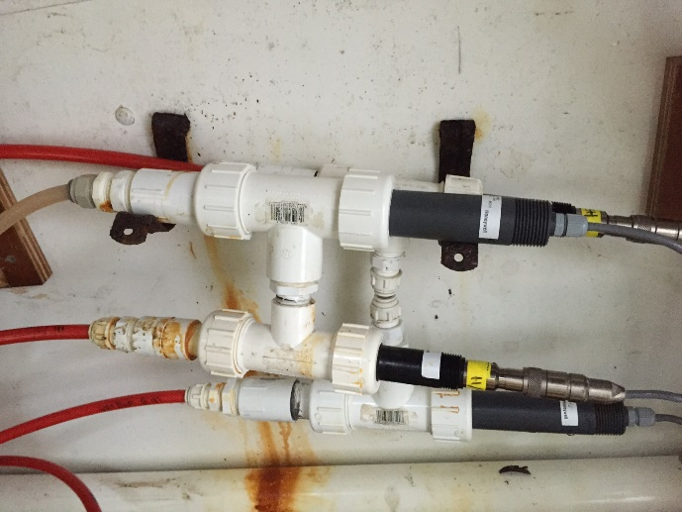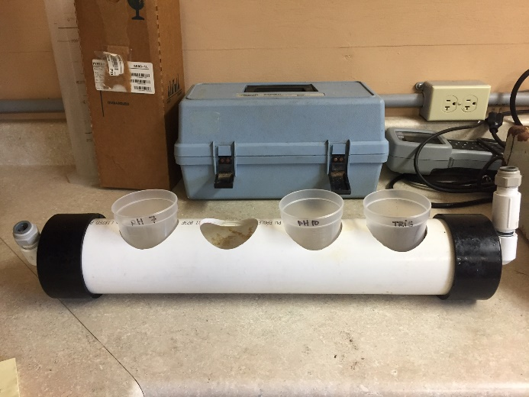

Photo 1 Photo 2

We use Oakton calibration buffers 7 and 10 that we buy from Cole-Palmer. I cool them down to the temperature at which we plan to use the Durafet probes by using a high-tech ☺ continuously flowing water-bath (Photo 2). I wait for about 30 minutes with the buffers covered to ensure no contamination and then start a 2- point calibration starting with pH7. Note: Always rinse the Durafet with the buffer in which you are about to use. When the buffer temperature has acclimated to your water-bath temperature, place the Durafet in the pH7 buffer and wait 5 minutes for the probe to detect the correct temperature of the buffer. Press the calibration button on the Honeywell UDA2182, then select Input PV Cal, then Input 1 or 2 (whichever one you want to calibrate), then BUFFER CAL. Press enter when pH is stable. Note: At 10 minutes, the Honeywell will automatically close down the calibration and you will have to start it all over. After pressing enter, the pH value will then start blinking and this is your opportunity to change the pH value. Use the “pH Calibration Curves” worksheet to determine what your pH should be at the temperature your buffer is at. Press enter and continue following the prompts on the Honeywell display. It will then tell you to place in the next buffer so first rinse the Durafet with the pH10 buffer and then place in the pH10 buffer. Wait about 5 minutes to stabilize and then press enter to change your pH value. Again, use the calibration curve to determine what your pH10 buffer should be at that temperature. Press enter after you change your pH value and follow the directions on the screen until you see CALIBRATION COMPLETE, then exit. You are now in NBS scale after finishing this temperature adjusted two point-calibration.

To shift your scale to total, you will want to use the TRIS buffer which should shift your slope down by approximately 0.13. This is a 1-point calibration. Starting from the original default screen, press the calibration button, then select Input PV cal, then Input 1 or 2, then SAMPLE CAL. Rinse probe with TRIS buffer and place in TRIS buffer. Wait until the pH stabilizes before pressing enter to change the pH. Use the “pH Calculator (TRIS/AMP)” worksheet to determine what your pH should be at the temperature your TRIS buffer is at. Press enter and follow the prompts until you see CALIBRATION COMPLETE, then exit. For example, if the Durafet reads 8.40 in your TRIS buffer and your TRIS pH should be 8.27 according to your calibration curve, that is a SUCCESS, calibrate down to 8.27! You are now in TOTAL scale. Hooray!

I used to calibrate every month but now I mainly just troubleshoot as needed when I begin to see a progressive deviation between the Durafet values and the calculated pH values (from PCO2 and TCO2). The idea with the Durafet is that you are NOT supposed to calibrate them; sometimes all they need is to be cleaned.

**TRIS Recipe**

This is a recipe to make 1L of TRIS Buffer (0.08M) with a salinity of 28ppt. If you need a different salinity, you can recalculate the amount of ingredients to add by changing the target salinity in the “TRIS buffer recipe” worksheet.

Use a 1L volumetric flask and add about 100 ml of dH20 to have some liquid to dissolve your salts into. Weigh out the first ingredient, make a slurry using a squirt bottle of dH20, and add to the volumetric flask using a funnel. Mix well by capping the flask and inverting several times. When dissolved, move onto the next ingredient and repeat. Follow in order. When everything is dissolved, add dH20 to a final volume of 1L.

NaCI: 21.073g

KCl: 0.789g

MgSO4- (H20)7: 7.214g

CaCl2 dihydrate: 1.580g

HCl (37%): 3.34mL

TRIS: 9.684g